
Bariatric Bed Algorithm
Weight > 350 lbs

Algorithm available at:
http://infonet/nursing/tissue_integrity/bariatric_bed_algorithm.pdf

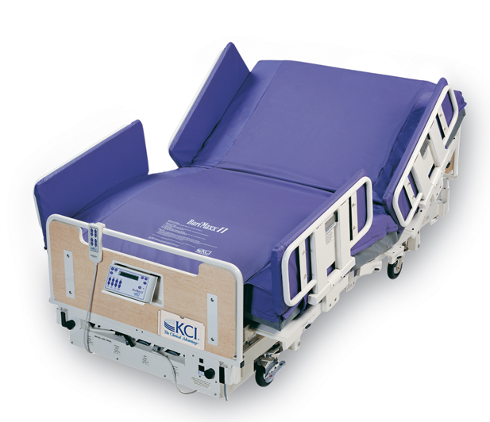
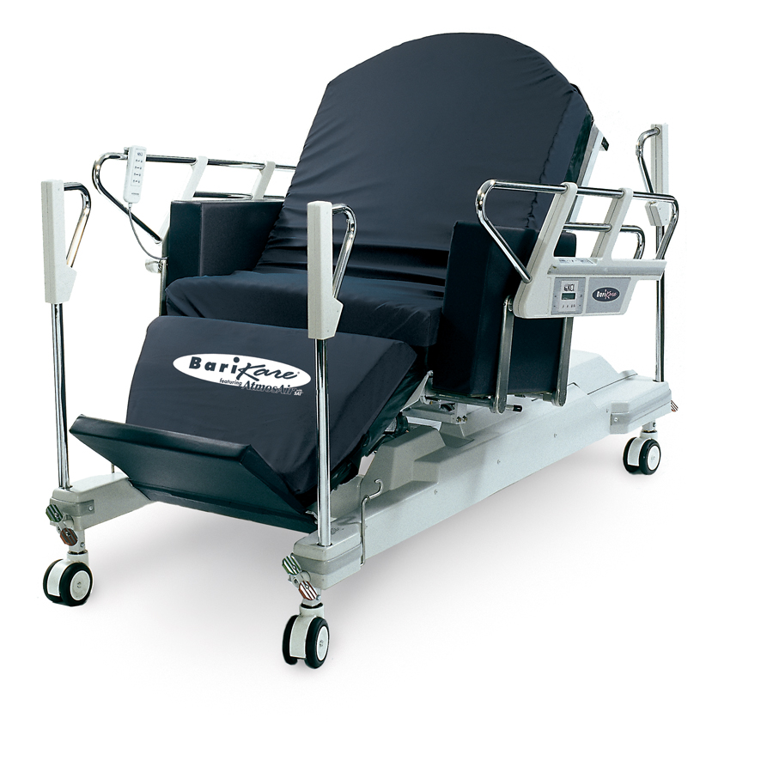
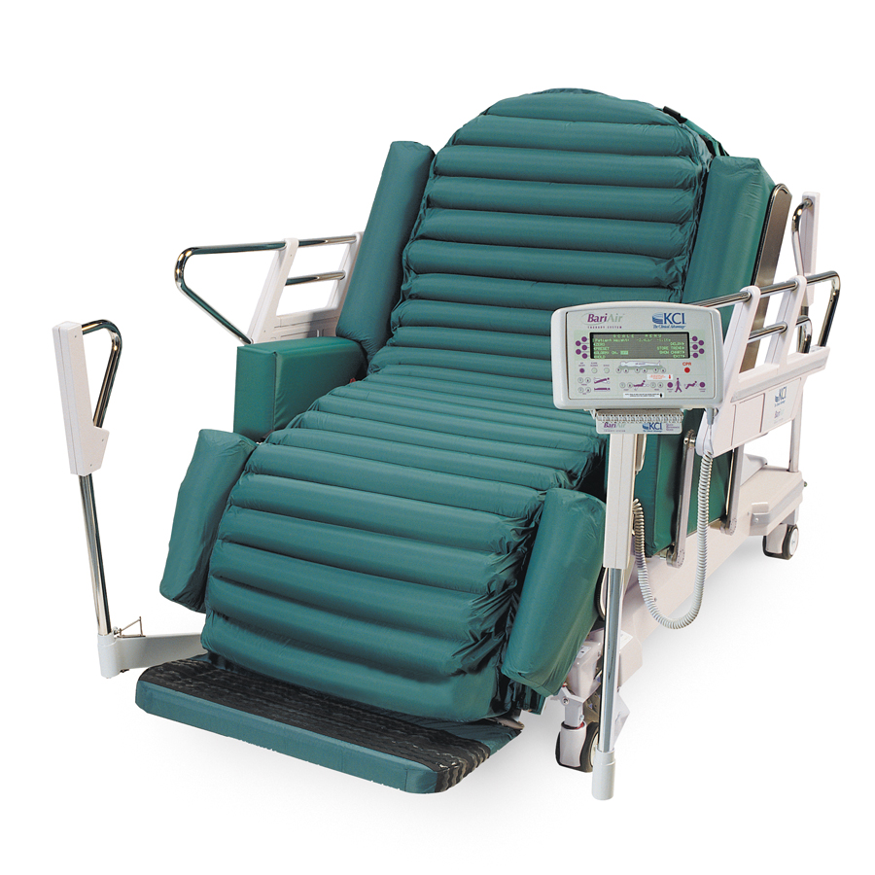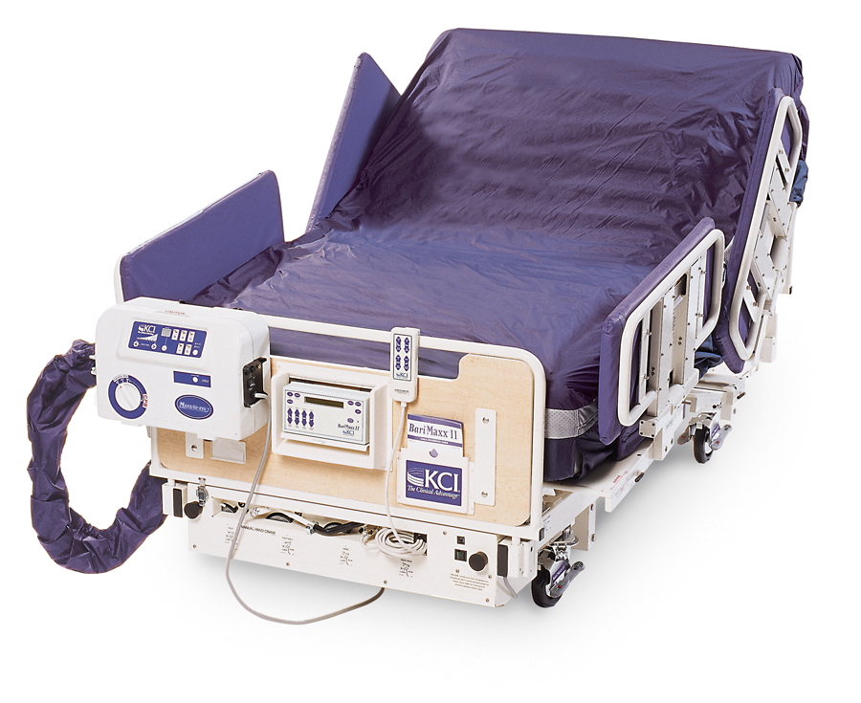
BariMaxx II with ETS (air) mattress
(side exit/wider)
Pressure relief
BariKare Bed
(foot exit)
Pressure relief (no air loss)
Must be >5’4” or <6’ tall
BariMaxx II
(side exit/wider)
Pressure reduction
BariAir
(foot exit)
Pressure relief
Must be >5’4” or <6’

Treatment Surface
No Breakdown
or
Stage I pressure ulcer without immobility
or
Braden score 13 or >

Breakdown to coccyx/sacrum or trochanters
Stage III-IV pressure ulcer
or
Stage II with severe immobility
or
Braden score <13

Breakdown to heels/malleolus:
Position with pillow to keep bony prominences off mattress.
Evaluate for need for PRAFFO boots/cage splint/AFO.
Breakdown to occiput: Avoid use of pillow when supine.
Use foam donut instead.
Breakdown to ears: Use foam donut in side-lying position around ear.

